**Water level Monitoring System:**

Link of Simulation: <https://www.tinkercad.com/things/e3W2fdkuE0b-copy-of-smart-irrigation-with-soil-moisture-sensor-and-relay/editel?tenant=circuits>..

Code Used For Simulation:

#define moisturepin A0

#define pump 7

int moisturevalue = 0;

int lastmoisturevalue = -1;

void setup()

{

Serial.begin(9600);

pinMode(pump, OUTPUT);

pinMode(moisturepin, INPUT);

}

void loop()

{

moisturevalue = analogRead(moisturepin);

if (moisturevalue != lastmoisturevalue) {

lastmoisturevalue = moisturevalue;

if (moisturevalue <= 300) { digitalWrite(pump, HIGH); Serial.println("Soil Humidity = " + String(moisturevalue) + "% - Pump ON");

} else {

digitalWrite(pump, LOW); Serial.println("Soil Humidity = " + String(moisturevalue) + "% - Pump OFF");

}

}

delay(100);

}

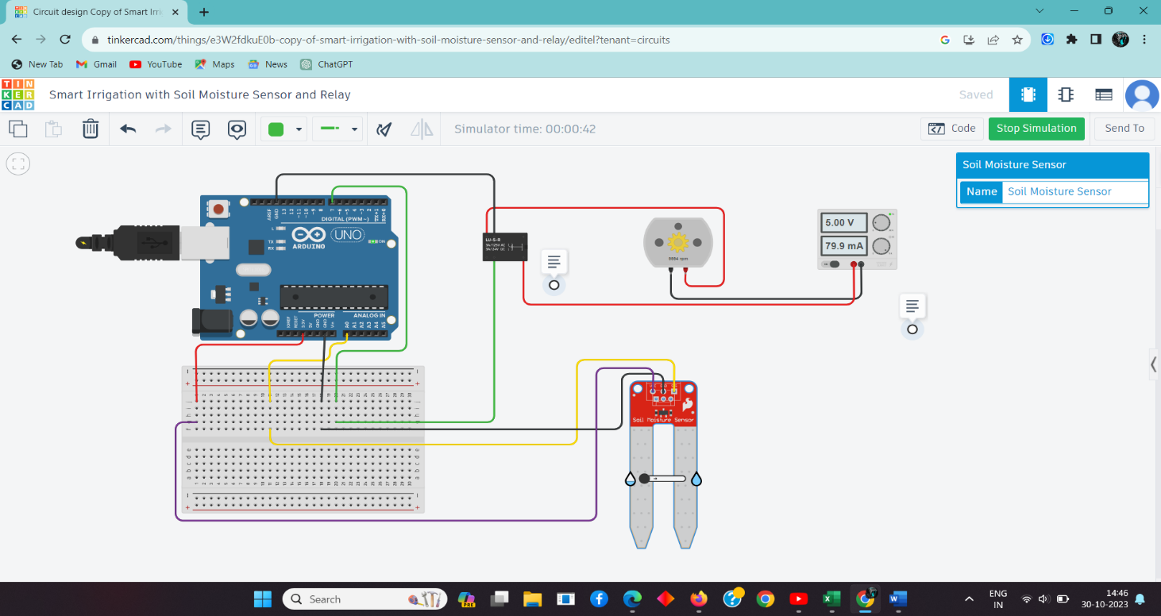Before threshold:(Motor ON)

After Threshold:(Motor OFF)